- Design and Configuration of Star Topologies using Packet Tracer
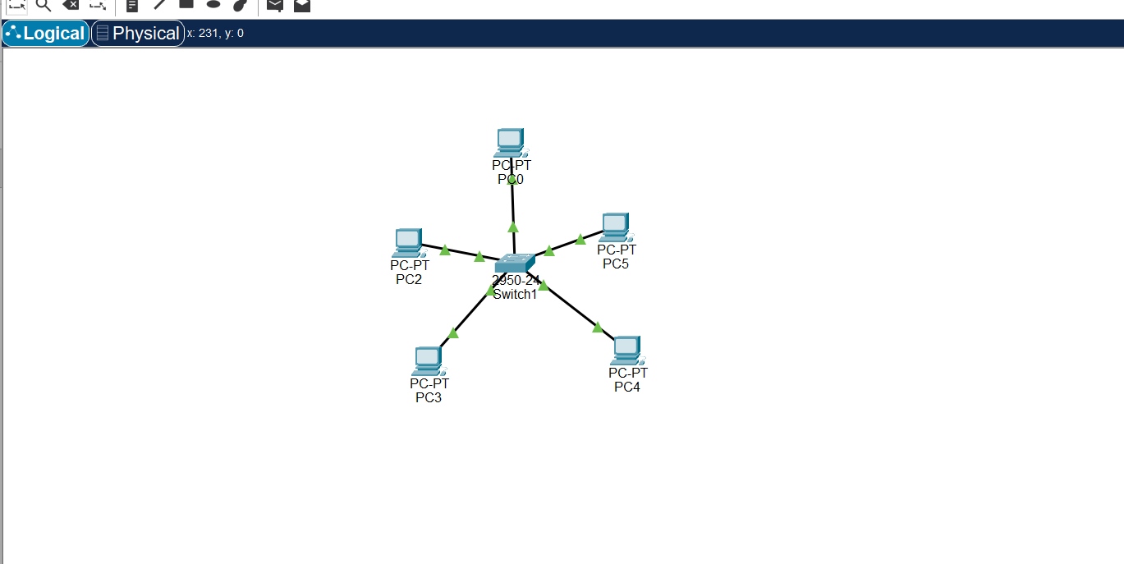
- Design and Configuration of BUS Topologies using Packet Tracer.
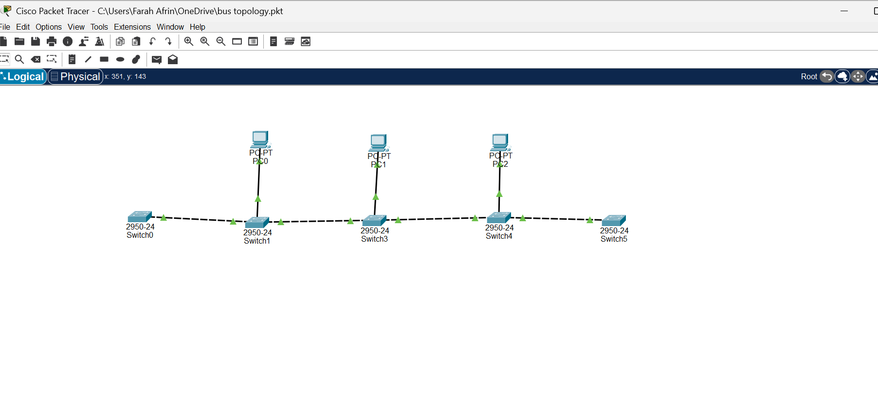
- Design and Configuration of RING Topologies using Packet Tracer.
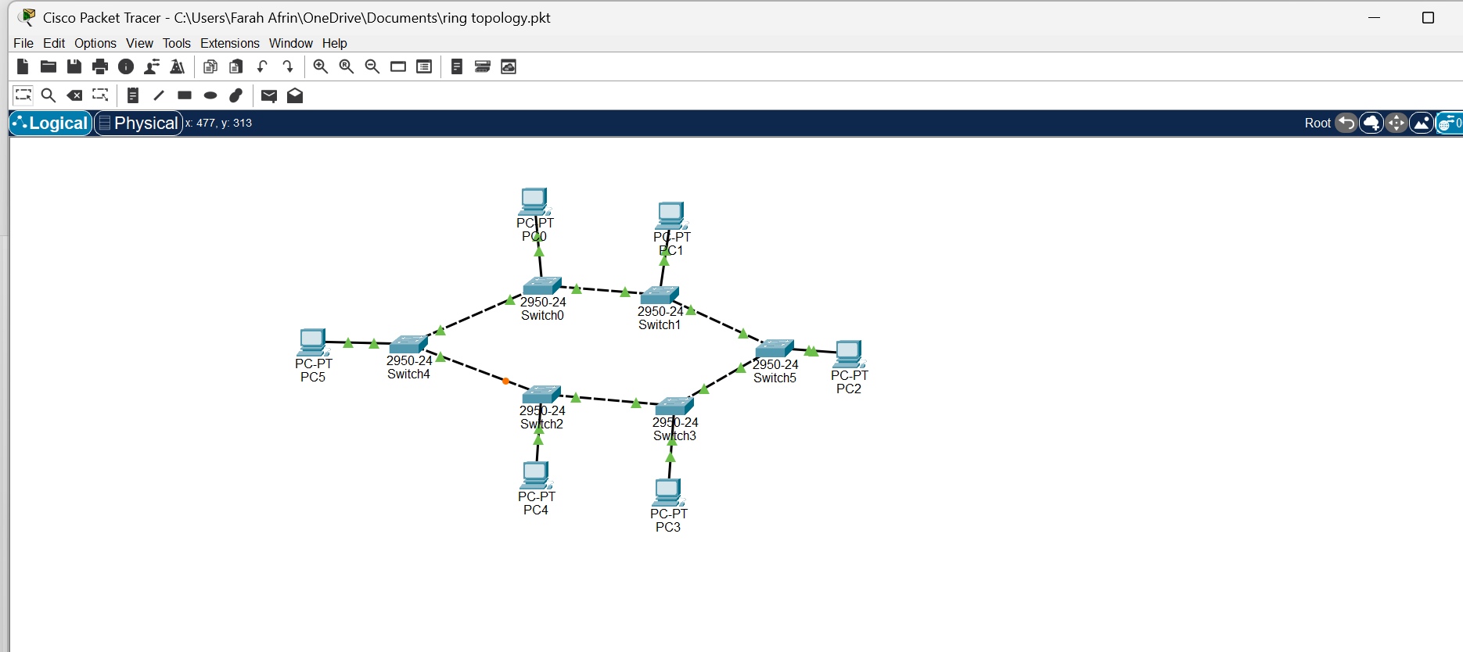
- Design and Configuration of Mesh Topologies using Packet Tracer.
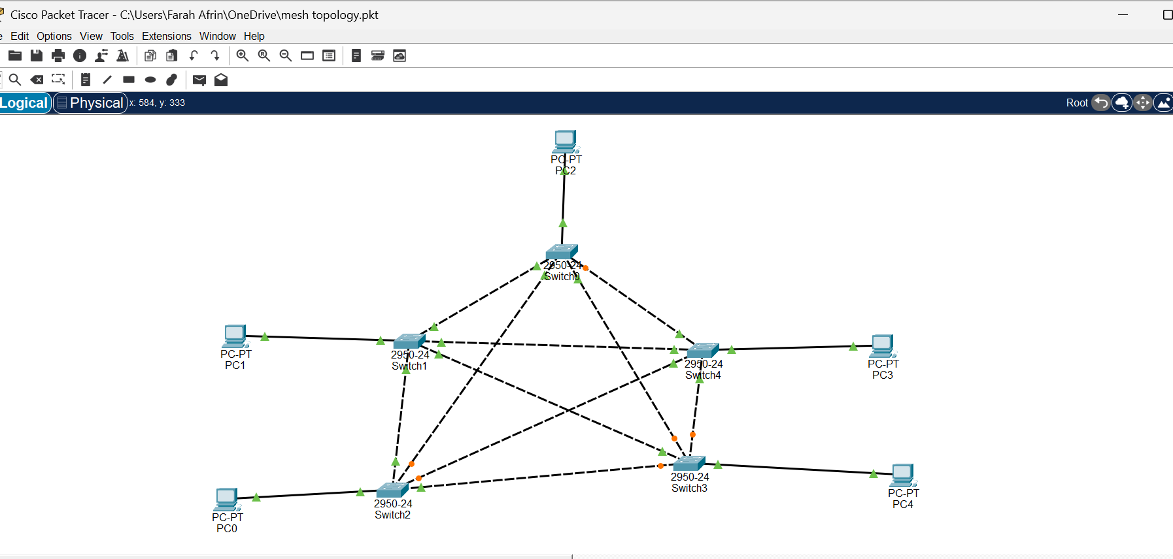
- Design and Configuration of Tree Topologies using Packet Tracer.
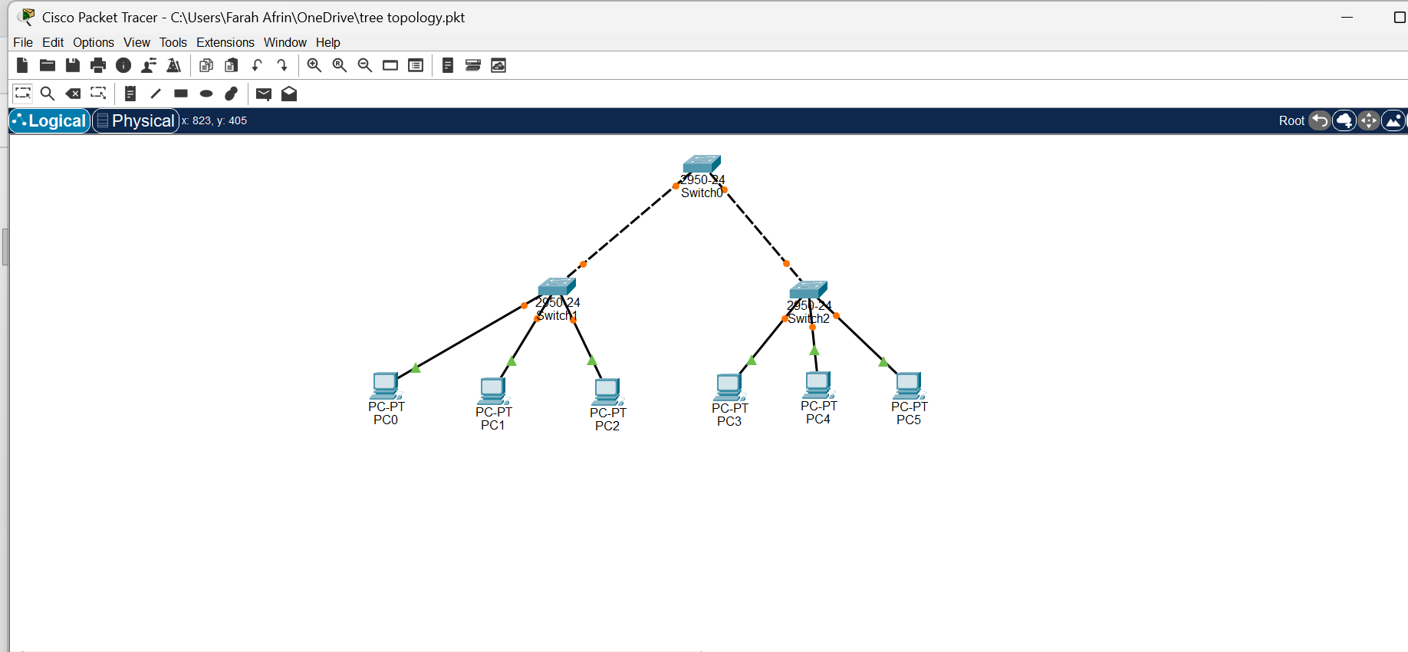
- Design and Configuration of Hybrid Topologies using Packet Tracer.
